Jal Rekha

High Level Design (HLD) Document

Bharosa Module (Factory Testing)
01-JAN-2026



Madhya Pradesh State Electronics Development Cooperation State IT Centre, 47-A, Arera Hills, Bhopal
https://mpsedc.mp.gov.in/

Project: Jal Rekha Water Management System
Module: Bharosa – Factory Testing Details
Organization: Madhya Pradesh Jal Nigam Department
Developed By: MPSeDC
Document Type: High Level Design (HLD)
Compliance: CMMI DEV Level-5
Version: 1.0

Date: January 2026

TABLE OF CONTENTS

- Introduction
- Purpose
- Scope
- Definitions & Abbreviations
- System Overview
- Architectural Principles
- System Architecture Diagram
- Functional Architecture Diagram
- Deployment Architecture Diagram
- Data Flow Diagram (DFD)
- Sequence Diagrams
- Database Design – ER Diagram
- Security Architecture
- Performance Architecture
- Scalability & Reliability
- Audit & Compliance Architecture
- Risk Mitigation Strategy
- Traceability Matrix
- Conclusion

1. INTRODUCTION

The Bharosa Module under the Jal Rekha Water Management System is a mission-critical digital platform designed to strengthen quality assurance, operational transparency, and compliance monitoring across all water supply infrastructure projects implemented by the Madhya Pradesh Jal Nigam Department.
This module provides a centralized, standardized, and auditable mechanism for managing factory testing, third-party inspections, and vendor performance tracking, ensuring that all components used in water supply schemes strictly adhere to national quality standards, project specifications, and regulatory requirements

Key Functional Objectives
The Bharosa Module aims to achieve the following objectives:
- Establish end-to-end traceability of factory testing activities.
- Enable real-time visibility into inspection status and quality metrics.
- Ensure transparent and accountable engagement of Third Party Inspection Agencies (TPIA).
- Strengthen vendor quality performance monitoring.
- Provide data-driven decision support for project management and policy formulation.
- Ensure audit-ready documentation and compliance with CMMI Level-5 and government IT governance frameworks.

2. PURPOSE
This HLD document defines:
- System architecture
- Functional components
- Data flow & interaction
- Security & compliance framework
- Database design
As per CMMI DEV Level-5 standards.

3. SCOPE
This document covers:
- Factory Testing Survey Inspection (FTSI)
- Factory Testing Details (FTD)
- Search & Filtering
- Export & Reporting
- Vendor & TPIA management

4. DEFINITIONS & ABBREVIATIONS

Term | Description
HLD | High Level Design
FTSI | Factory Testing Survey Inspection
FTD | Factory Testing Details
TPIA | Third Party Inspection Agency
PIU | Project Implementation Unit
QA | Quality Assurance
RBAC | Role Based Access Control

5. SYSTEM OVERVIEW
The Bharosa Factory Testing Module provides:
- Centralized quality data management
- Vendor performance monitoring
- Inspection traceability
- KPI-based reporting
- Compliance-ready audit logs

6. ARCHITECTURAL PRINCIPLES
Principle | Description
Modularity | Component-based architecture
Loose Coupling | Independent services
High Cohesion | Single responsibility
Security First | RBAC + audit
Scalability | Horizontal scaling
Reliability | Fail-safe design
Auditability | Full logging

7. SYSTEM ARCHITECTURE DIAGRAM (LOGICAL VIEW)

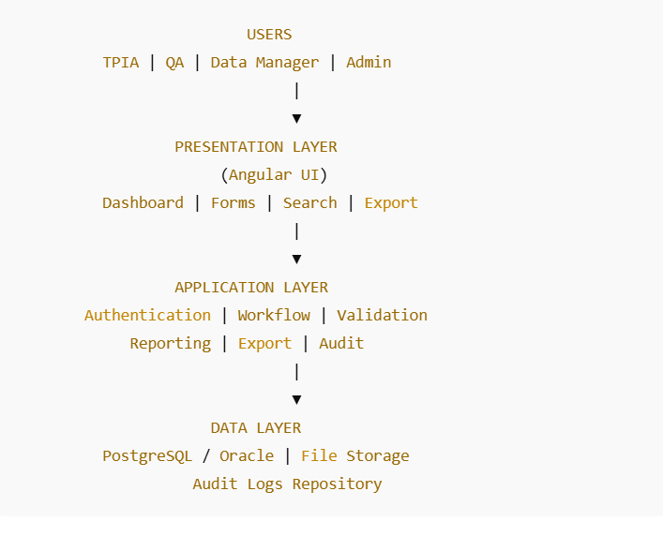

8. FUNCTIONAL ARCHITECTURE DIAGRAM
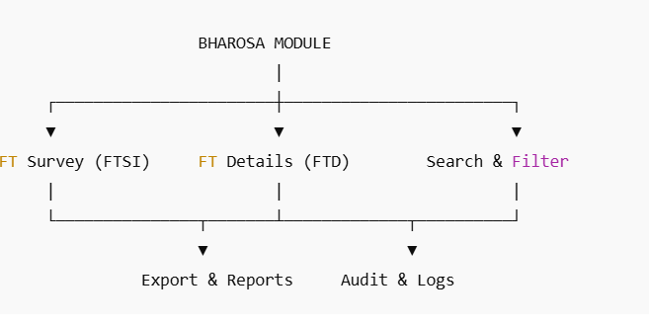

9. DEPLOYMENT ARCHITECTURE DIAGRAM

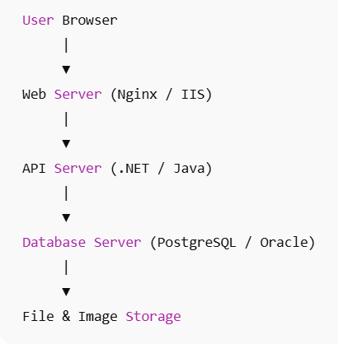

10. DATA FLOW DIAGRAM (DFD – LEVEL 1)

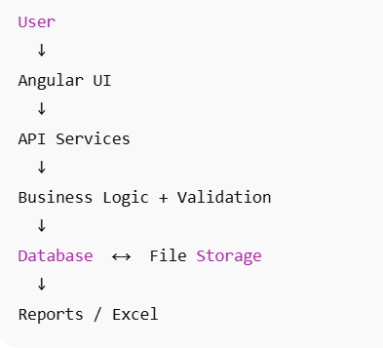

11. SEQUENCE DIAGRAMS

11.1 Add Factory Testing Details

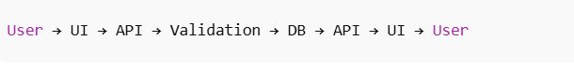
Steps:
- User fills form
- UI sends request
- API validates data
- Data stored in DB
- Audit log generated
- Confirmation shown
11.2 Search & Filter

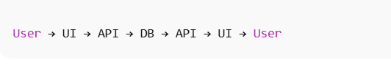

11.3 Export to Excel

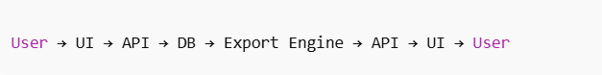

12. DATABASE DESIGN – ER DIAGRAM

12.1 Entities
PIU
SCHEME
COMPONENT
SUB_COMPONENT
ITEM_MASTER
VENDOR_MASTER
TPIA_MASTER
FACTORY_TESTING_DETAILS
FACTORY_SURVEY_INSPECTION
USER_MASTER
AUDIT_LOG

12.2 ER DIAGRAM

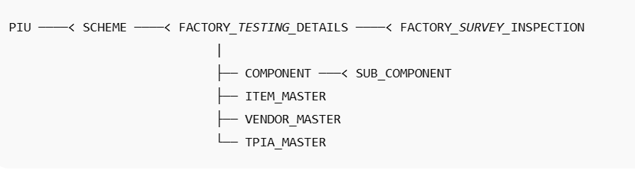

12.3 Core Tables

FACTORY_TESTING_DETAILS
Column | Type
ftd_id (PK) | bigint
scheme_id (FK) | bigint
component_id | bigint
sub_component_id | bigint
item_id | bigint
vendor_id | bigint
tpia_id | bigint
created_date | timestamp

FACTORY_SURVEY_INSPECTION
Column | Type
ftsi_id (PK) | bigint
ftd_id (FK) | bigint
inspector_name | varchar
ordered_qty | int
inspected_qty | int
failed_qty | int
image_path | varchar

13. SECURITY ARCHITECTURE



Security Controls:
- Role Based Access Control
- Secure authentication
- SQL injection protection
- Input sanitization
- Encrypted communication (HTTPS)
- Export audit logging

14. PERFORMANCE ARCHITECTURE
Parameter | Target
UI Load | < 2 sec
Search | < 3 sec
Export 10k rows | < 20 sec

Optimizations:
- Indexed queries
- Pagination
- Async exports

15. SCALABILITY & RELIABILITY
- Stateless API services
- Horizontal scaling
- Load balancing
- Failover database
- Backup & Disaster Recovery

16. AUDIT & COMPLIANCE ARCHITECTURE

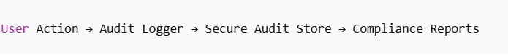

Maintains:
- Data change history
- Export history
- Login audit

Compliance:
CMMI DEV Level-5 + Government IT Audit Standards

17. RISK MITIGATION STRATEGY

Risk | Mitigation
Data loss | Backup + DR
Unauthorized access | RBAC + logs
Performance | Indexing + caching
Data inconsistency | Validation engine

18. TRACEABILITY MATRIX
Requirement | Design
Add testing | UI + API + DB
Search | Filter engine
Export | Export engine
Security | RBAC
Audit | Audit service

19. CONCLUSION
This HLD document provides a complete architectural blueprint for the Bharosa Factory Testing Module, fully compliant with CMMI DEV Level-5 standards and Government IT audit requirements.

